Missing at Random (MAR) Analysis Report
Following IUPAC Standards for Analytical Data Quality Assessment

Report Generated: | 2026-04-27 05:05:31
Dataset Name: | MAR Analysis Dataset
Total Observations: | 363,881
Total Variables: | 18
Analysis Method: | IUPAC-Standard MAR Quantification Protocol v1.0

1. Executive Summary
This report presents a comprehensive Missing at Random (MAR) analysis of the dataset containing 363,881 observations across 18 variables. Overall, 45,850 missing values were detected, representing 0.70% of all data points.

Key Findings
• Variables Analyzed: 3 variables with missing data
• MAR Supported: 3 out of 3 variables
• Average MAR Score: 4.7/100 (No)

2. Analytical Methodology

2.1 IUPAC Standards Applied
This analysis follows IUPAC (International Union of Pure and Applied Chemistry) guidelines for analytical data quality assessment, adapted for missing data pattern detection. The methodology incorporates:
- Logistic Regression with AUC-ROC analysis for predictive power assessment
- Mann-Whitney U and Chi-square tests with effect size calculations (Cohen's guidelines)
- Mahalanobis distance for multivariate discriminant analysis
- Missingness correlation network analysis
- Weighted MAR quantification score (0-100 scale)

2.2 MAR Classification Criteria
MAR Score | Grade | Classification
70-100 | A | Strong MAR Evidence
50-69 | B | Moderate MAR Evidence
30-49 | C | Weak MAR Evidence
15-29 | D | Minimal MAR Evidence
0-14 | F | No MAR Evidence

3. Missing Data Overview
Variable | Data Type | Missing Count | Missing %
Birth_Weight(grams) | float64 | 45,303 | 12.45%
Race_of_Father | str | 531 | 0.15%
Birth_Order | str | 16 | 0.00%

4. MAR Analysis Results

4.1 Variable: Birth_Weight(grams)
Missing Percentage | 12.45%
MAR Score | 4.0/100
MAR Grade | Not available
MAR Supported | Yes
Confidence Level | Not available
Recommendation | Likely MAR - use imputation methods with caution

- Significant Associations Found:
Variable | Type | Effect Size | P-value
Birh_Year | numeric | N/A (inf) | 0.0000
Registered_District_2.0 | numeric | N/A (0.057) | 0.0000
Registered_Month2.0 | numeric | N/A (0.023) | 0.0000
Age of Mother | numeric | N/A (0.005) | 0.0040

4.2 Variable: Birth_Order
Missing Percentage | 0.00%
MAR Score | 5.0/100
MAR Grade | Not available
MAR Supported | Yes
Confidence Level | Not available
Recommendation | Likely MAR - use imputation methods with caution

- Significant Associations Found:
Variable | Type | Effect Size | P-value
Age of Mother | numeric | N/A (0.010) | 0.0000
Birh_Year | numeric | N/A (0.006) | 0.0007
Registered_Month2.0 | numeric | N/A (0.005) | 0.0011

4.3 Variable: Race_of_Father
Missing Percentage | 0.15%
MAR Score | 5.0/100
MAR Grade | Not available
MAR Supported | Yes
Confidence Level | Not available
Recommendation | Likely MAR - use imputation methods with caution

- Significant Associations Found:
Variable | Type | Effect Size | P-value
Birh_Year | numeric | N/A (0.038) | 0.0000
Age of Mother | numeric | N/A (0.009) | 0.0000
Registered_District_2.0 | numeric | N/A (0.006) | 0.0008

5. Recommendations for Missing Data Handling

5.1 For MAR Variables
The following 3 variable(s) demonstrate MAR patterns and should be handled using model-based methods:
- Birth_Weight(grams), Birth_Order, Race_of_Father
Recommended Methods (IUPAC-endorsed):
- Multiple Imputation by Chained Equations (MICE)
- Full Information Maximum Likelihood (FIML)
- Expectation-Maximization (EM) Algorithm

6. Conclusion
The MAR analysis indicates no evidence of systematic missingness (average score: 4.7/100). Further investigation into MCAR or MNAR mechanisms is advised.
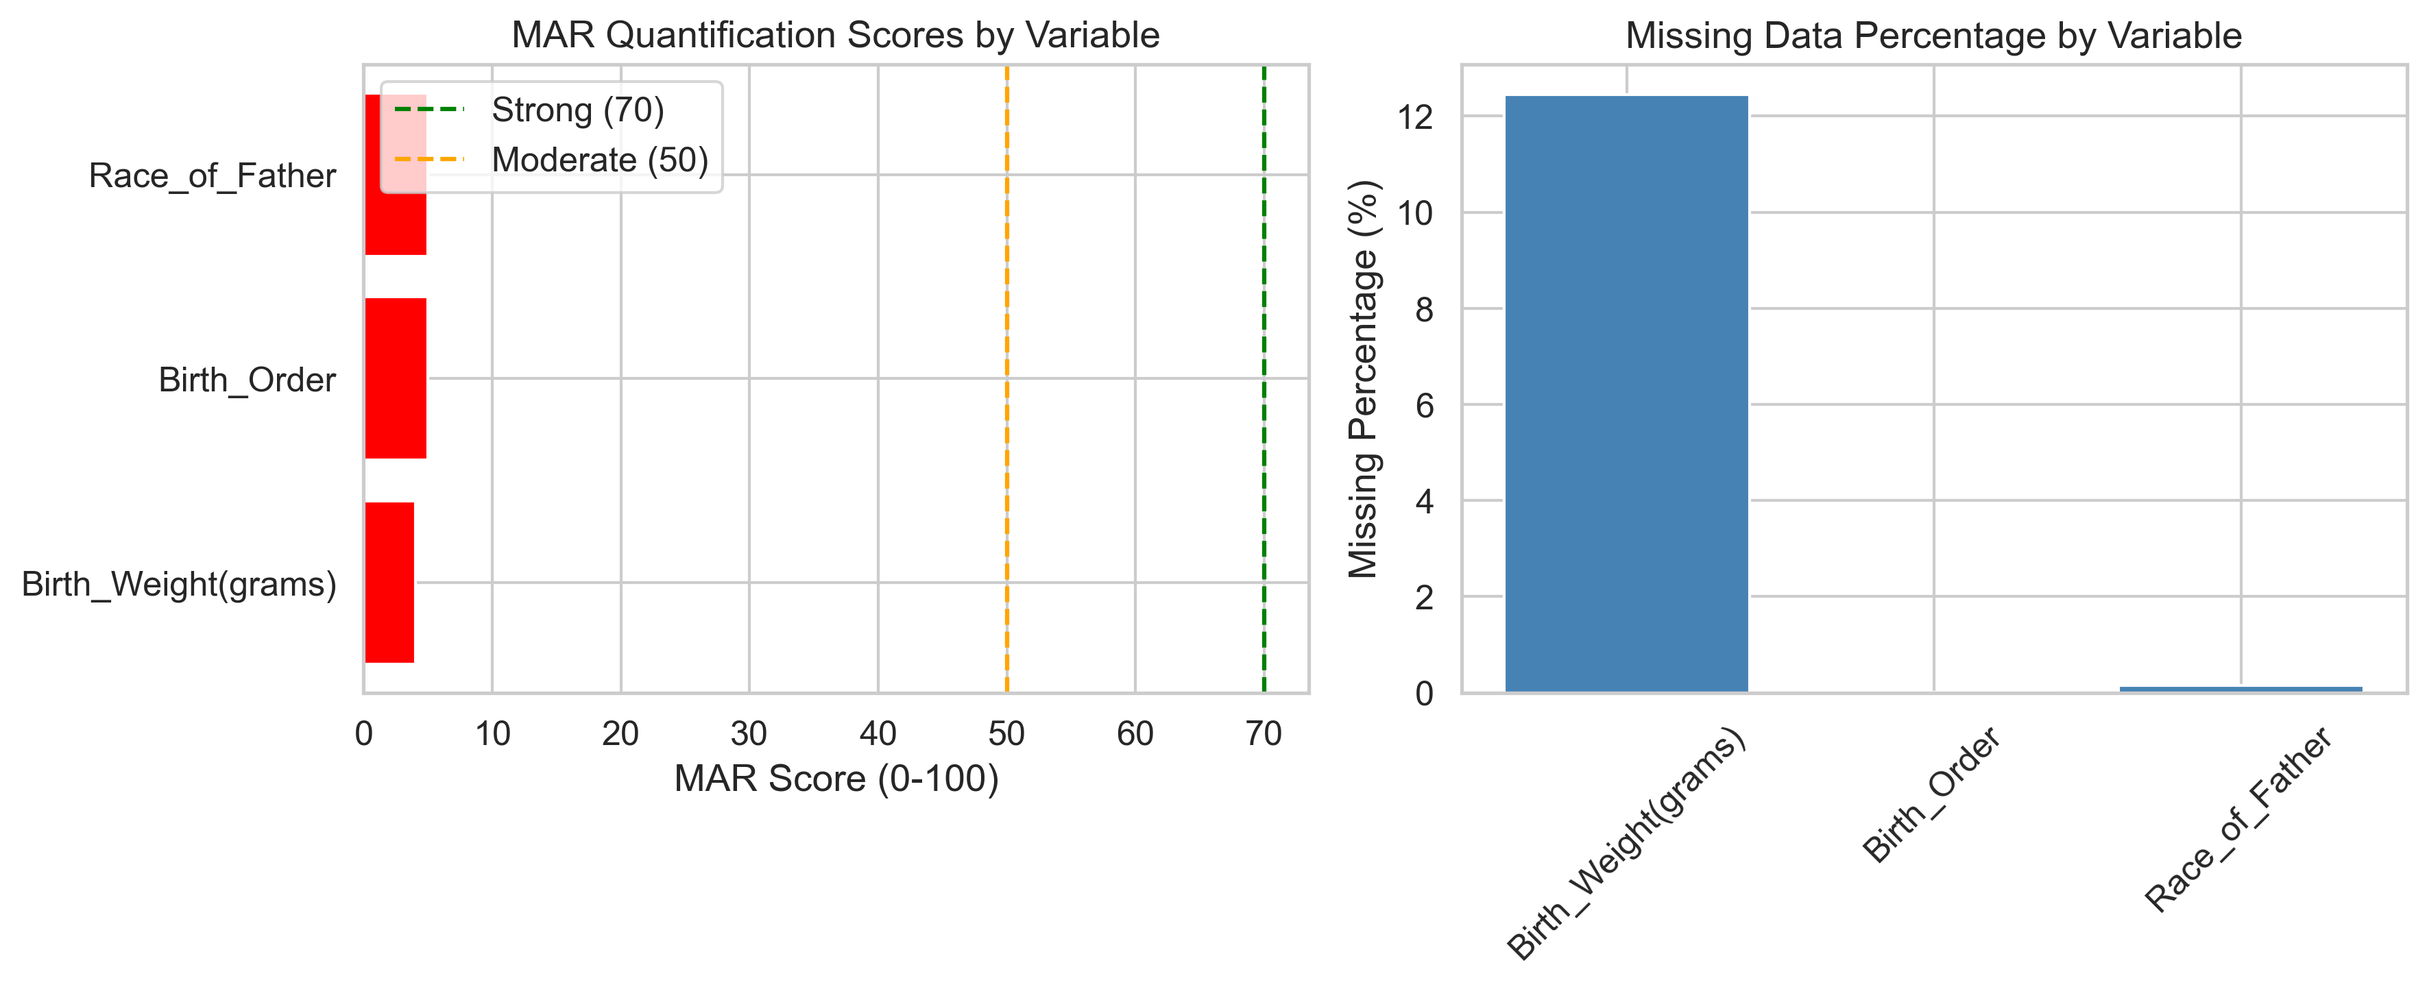
Figure 1: MAR Analysis Results Summary

References
1. IUPAC (2014). Harmonized guidelines for single-laboratory validation of methods of analysis. Pure and Applied Chemistry, 86(5), 775-796.
2. Rubin, D.B. (1976). Inference and missing data. Biometrika, 63(3), 581-592.
3. Little, R.J.A. (1988). A test of missing completely at random for multivariate data with missing values. Journal of the American Statistical Association, 83(404), 1198-1202.
4. Cohen, J. (1988). Statistical Power Analysis for the Behavioral Sciences (2nd ed.). Lawrence Erlbaum Associates.

